UNITED STATES DISTRICT COURT
FOR THE NORTHERN DISTRICT OF ALABAMA
Choose an item. DIVISION
Plaintiff(s).,  Plaintiff,  v.  Defendant(s).,  Defendant. | )  )  )  )  )  )  )  )  ) | Case No. :-cv-GMB
QUALIFIED HIPAA PROTECTIVE ORDER

This order grants to the parties the right, upon complying with the applicable discovery provisions of the Federal Rules of Civil Procedure, to obtain from any health care provider, health plan, or other entity covered by the Health Insurance Portability and Accountability Act of 1996, Pub. L. No. 104-191, 110 Stat. 1936 (1996) (“HIPAA”), any and all information relating to the past, present, or future medical condition of any individual who is a party to this action (or the decedent or ward of a party who sues in a representative capacity), as well as any and all information relating to the provision of health care to this individual and payment for the same.
This order also authorizes any third party who receives a subpoena requesting the production of documents or commanding attendance at deposition or trial to disclose protected health information in response to the subpoena. The court authorizes these disclosures under HIPAA’s privacy regulations. See 45 C.F.R.
§ 164.512(e)(1)(i).
The court prohibits the parties from using or disclosing this protected health information for any purpose other than as required in this action. Immediately upon the conclusion of this case, the parties must either return the protected health information to the covered entity from whom they obtained it or destroy the protected health information (including all copies made). See 45 C.F.R.
§§ 164.502(b) & 164.512(e)(1)(v).
DONE and ORDERED on July 1, 2022.
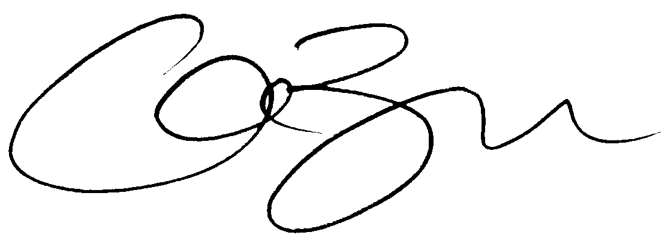

_________________________________
GRAY M. BORDEN
UNITED STATES MAGISTRATE JUDGE

